

# 3 Weeks Namibia

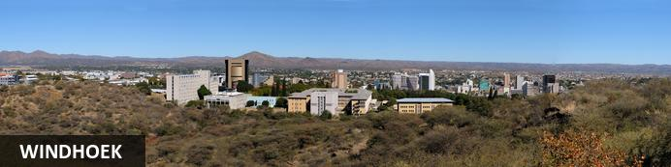

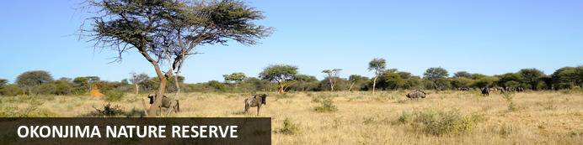

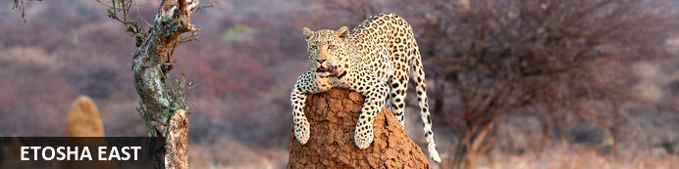

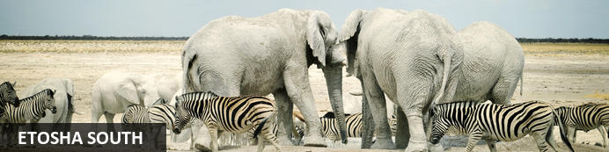

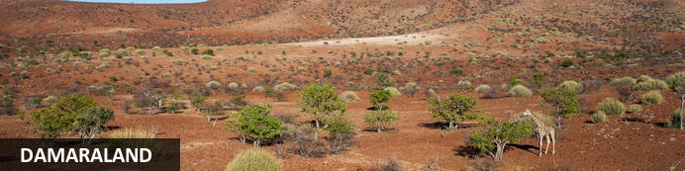

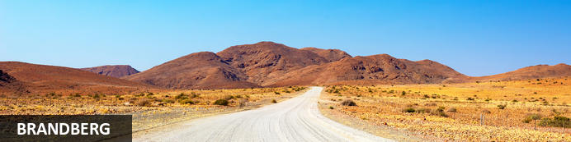

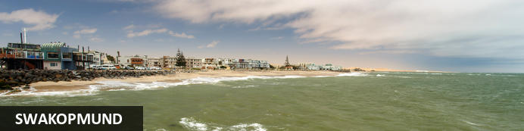

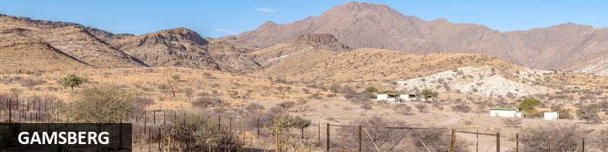

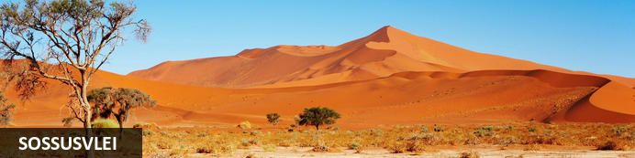

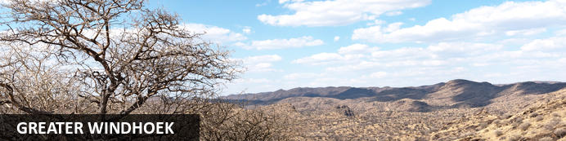

# Tour Namibia

# 3 Weeks Namibia

*Windhoek - Okonjima Nature Reserve - Etosha East - Etosha South - Damaraland - Brandberg - Swakopmund - Gamsberg - Sossusvlei - Greater Windhoek*  
*22 Days / 21 Nights*  
*2 Persons*  
*Date of Issue: 25 February 2025*  
**05 February 2025 - 26 February 2025**

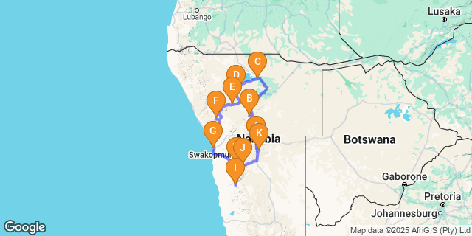

# [Click here to view your Digital Itinerary](https://wetu.com/Itinerary/Landing/295B6B72-48C6-4203-BFAD-920E6ACBFDCB)

## Introduction

|  |  |  |  |  |  |  |
| --- | --- | --- | --- | --- | --- | --- |
| **Accommodation** | **Destination** | **Start** | **End** | **Basis** | **Room Type** | **Duration** |
| [Immanuel Lodge](https://wetu.com/iBrochure/43610_29060) | Windhoek | 5 Feb | 7 Feb | B&B | 1x Double Room | **2 Nights** |
| [Okonjima Plains Camp](https://wetu.com/iBrochure/43610_8727) | Okonjima Nature Reserve | 7 Feb | 8 Feb | D,B&B | 1x Double Room | **1 Night** |
| [Mushara Bush Camp](https://wetu.com/iBrochure/43610_20477) | Etosha East | 8 Feb | 10 Feb | D,B&B | 1x Double Room | **2 Nights** |
| [Toshari Lodge](https://wetu.com/iBrochure/43610_10559) | Etosha South | 10 Feb | 12 Feb | D,B&B | 1x Double Room | **2 Nights** |
| Mountain Peak Game Lodge | Damaraland | 12 Feb | 13 Feb | D,B&B | 1x Double Room | **1 Night** |
| Brandberg White Lady Lodge | Brandberg | 13 Feb | 15 Feb | B&B | 2x Double Room | **2 Nights** |
| [Swakopmund Sands Hotel](https://wetu.com/iBrochure/43610_34719) | Swakopmund | 15 Feb | 18 Feb | B&B | 1x Double Room | **3 Nights** |
| Rostock Ritz Desert Lodge | Gamsberg | 18 Feb | 19 Feb | B&B | 1x Double Room | **1 Night** |
| [Le Mirage Resort & Spa](https://wetu.com/iBrochure/43610_10424) | Sossusvlei | 19 Feb | 22 Feb | D,B&B | 1x Double Room | **3 Nights** |
| Namibgrens Guest Farm | Gamsberg | 22 Feb | 23 Feb | D,B&B | 1x Double Room | **1 Night** |
| GocheGanas Lodge | Greater Windhoek | 23 Feb | 25 Feb | D,B&B | 1x Double Room | **2 Nights** |
| [Immanuel Lodge](https://wetu.com/iBrochure/43610_29060) | Windhoek | 25 Feb | 26 Feb | B&B | 1x Double Room | **1 Night** |

**Key**  
B&B: Bed and Breakfast  
D,B&B: Dinner, Bed and Breakfast

## Day 1: Immanuel Lodge, Windhoek (Wed, 5 February)

### Windhoek

Situated in Central Namibia, the cosmopolitan city of Windhoek serves as the capital of the country. It is home to an international airport and a plethora of restaurants, shops, entertainment venues and accommodation options. The city is clean, safe and well-organised, with a colonial legacy that is reflected in its many German eateries and shops, and the widespread use of the German language. Windhoek has an interesting mix of historical architecture and modern buildings, many of which are worth a look, including the Alte Feste an old fort, the 1896 Christuskirche Christ Church, and the more contemporary Supreme Court.

### Overnight: Immanuel Lodge [View iBrochure](https://wetu.com/iBrochure/43610_29060)

Immanuel Wilderness Lodge is located 20 km north of Windhoek. Surrounded by African Savannah in a growing suburb of the capital, the lodge offers a garden, outdoor pool and restaurant.

The Afro-chic rooms at Immanuel Wilderness Lodge are fitted with a private bathroom and tea-and-coffee making facilities. The beds are draped with a mosquito net. Linen and towels are provided.

Guests can start their day with a breakfast, which is served at the restaurant or on the terrace. Meals are available and the owner is a renowned chef.

If you are looking for a truly Namibian safari experience complete with personal service and warm hospitality, look no further than the exceptional Immanuel Wilderness Lodge.

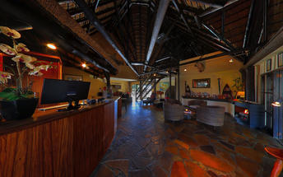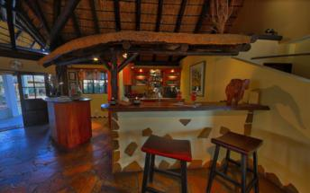

### Basis

Bed and Breakfast

## Day 2: Immanuel Lodge, Windhoek (Thu, 6 February)

### Basis

Bed and Breakfast

## Day 3: Okonjima Plains Camp, Okonjima Nature Reserve (Fri, 7 February)

### Okonjima Nature Reserve

Midway between the spectacular Etosha National Park and the capital city of Windhoek, lies the well-known Okonjima Nature Reserve. The 22 000 hectare nature reserve is home to AfriCAT, a carnivore sanctuary, which gives the captive cats a second chance to be released back into the wild and become completely independent hunters in a protected area right in the middle of commercial cattle farmland. Visitors can enjoy a stay at a variety of excellent accommodation options including everything from luxury villas to secluded camping. Don't miss the opportunity to enjoy thrilling cat-tracking guided safaris, leopard-spotting, off-road night drives and learn about local San culture along the Bushmen trail.

### Overnight: Okonjima Plains Camp [View iBrochure](https://wetu.com/iBrochure/43610_8727)

Okonjima Plains Camp is within the secluded wilderness area of Okonjima Nature Reserve and has majestic sunset views. Its design honours the Hanssen’s family cattle-farming history with its accommodation facility of 10 large View Rooms and 14 spacious Classic Rooms. The Plains Camp Barn includes a dining and lounge area, a curio shop and a terrasse with views over a waterhole and the Okonjima plains.

Game drives in search of elusive leopards and guided bush walks offer visitors an intimate, up-close perspective of Namibia’s wildlife and, especially, its most protected species. Whether you hike or are an avid bird watcher, there are endless ways to spend your time at Okonjima.

Okonjima Nature Reserve is recognized as one of the premier places to stay to witness carnivores and other endangered species like the aardvark, pangolin and brown hyaena in the wild and to be educated about conservation. The AfriCat Foundation was born in the early 1990’s, a Namibia registered non-profit organization which started out primarily as a welfare organization, and has since become focused on research projects which are essential in accomplishing its mission of the long term conservation of Namibia’s wildlife.

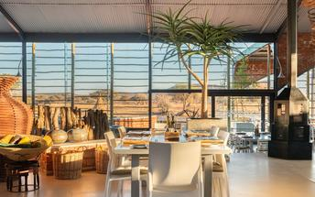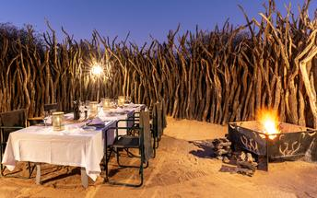

|  |
| --- |
| Directions - Immanuel Lodge to Okonjima Plains Camp |
| **Distance:** 203.64km **Travel Time:** 2:16 hours |
| **GPS co-ordinates for Okonjima Plains Camp:** S 20° 51' 34.465" E 16° 38' 26.919" |
| * Head west (0.3 km)http://schemas.openxmlformats.org/drawingml/2006/picture * Turn right (0.3 km) * Turn right (0.9 km) * Turn left to merge onto A1 (52.3 km) * Continue onto B1 (127 km) * Turn left (17.4 km) * Turn left (0.7 km) * Slight right (24 m) * Keep left (0.3 km) * Turn right (1.8 km) * Turn left (0.1 km) * Slight right (0.3 km) * Slight left (1.5 km) * Turn right (0.3 km) * Turn right (19 m) * Continue straight (0.4 km) * Turn right (0.1 km) * Turn right (50 m) * Turn right. Destination will be on the right (41 m) |
| *Directions supplied by Google.* |

### Basis

Dinner, Bed and Breakfast

## Day 4: Mushara Bush Camp, Etosha East (Sat, 8 February)

### Etosha East

Located in Northwestern Namibia, Etosha East is a protected sanctuary in the eastern part of the world-renowned Etosha National Park, known as one of the most accessible game reserves in Southern Africa. Etosha East boasts vast open plains scattered with semi-arid savannah grasslands dotted with watering holes and secluded bush camps. An impressive 5000-square-kilometre Etosha salt pan makes up a large area of the eastern side of the park and can even be seen from space. This remote area teems with abundant wildlife such as lions, elephants, black rhinos and giraffes, as well as a variety of birdlife featuring flamingos, ostriches, eagles, hornbills, and owls.

### Overnight: Mushara Bush Camp [View iBrochure](https://wetu.com/iBrochure/43610_20477)

MUSHARA BUSH CAMP

Mushara Bush Camp is situated a mere 10 kilometers from the Von Lindequist gate of the world famous Etosha National Park. The Mushara Bush Camp offers a down-to-earth tented bush camp experience which is well suited as a basis base for independent travelers and families exploring the magical Etosha Pan National Park.

The main Bush Camp House is thatched and has a true bush camp feel to it. The early evenings see a campfire lit where guest can exchange stories of the day’s wildlife sightings. Dinner, lunch and breakfast are served on the thatched verandah with the bush being a mere step away. The Mushara Bush Camp is your optimal family destination on the doorstep to the magical Etosha National Park.

The 16 custom made en-suite tents are built from a combination of canvas, wood and local limestone. With their own 8 square metre private verandah and roof to floor windows, theses rooms are spacious and airy. Each large bathroom has an oversized window and shower looking into the surrounding bush. The brushed cement floors and lime stone walls keep the rooms cool from the afternoon sun. Four of these tents are ideally suited for families with small children as they have a  
sleeper couch for two children.

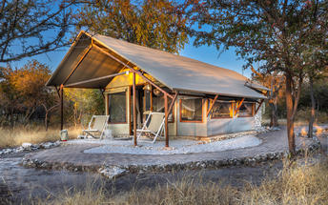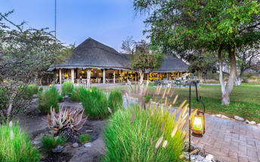

|  |
| --- |
| Directions - Okonjima Plains Camp to Mushara Bush Camp |
| **Distance:** 340.46km **Travel Time:** 3:35 hours |
| **GPS co-ordinates for Mushara Bush Camp:** S 18° 48' 48.928" E 17° 07' 42.866" |
| * Head southeast (41 m)http://schemas.openxmlformats.org/drawingml/2006/picture * Turn left (50 m) * Turn left at the 1st cross street (0.4 km) * Turn left (0.2 km) * Turn left (0.3 km) * Turn left (1.0 km) * Slight right (0.9 km) * Turn right (1.8 km) * Turn left (0.3 km) * Slight right (0.7 km) * Turn right (17.4 km) * Turn left onto B1 (227 km) * Turn left (0.2 km) * Continue onto B1 (75.5 km) * Turn left onto C38 (14.7 km) |
| *Directions supplied by Google.* |

### Basis

Dinner, Bed and Breakfast

## Day 5: Mushara Bush Camp, Etosha East (Sun, 9 February)

### Basis

Dinner, Bed and Breakfast

## Day 6: Toshari Lodge, Etosha South (Mon, 10 February)

### Etosha South

Located just south of the boundary of Etosha National Park in northwestern Namibia, Etosha South makes up the southern region of this wild paradise. The area is comprised of a collection of world class private game reserves. The national park can be accessed via the southern entrance at Andersson’s Gate. Visitors can catch a glimpse of a variety of wildlife including: lion, giraffe, elephant, white and black rhino, and a multitude of plains game. Popular activities include: enjoying an open 4x4 safari with an expert guide, half day or full day drives with the option of a picnic lunch with wine on the full day game drive.

### Overnight: Toshari Lodge [View iBrochure](https://wetu.com/iBrochure/43610_10559)

Nestled on an outcrop of Dolomite Rocks under a canopy of Mopane and White Seringa Trees, Toshari Lodge is just a 20-minute drive from the Andersson Gate, on the edge of the magnificent Etosha National Park. This makes it the perfect destination for day trips into Etosha, whether on your own or expertly guided by us.  
  
Our rooms offer comfort and convenience, equipped with mosquito nets, air-conditioning, coffee/tea stations, and outdoor sitting areas. Enjoy delicious meals served from our Buffet and Grill area, featuring a variety of local Game Meats. Relax at our Bar with an extensive wine list, and local Wines, Gins, and Beers.  
  
For a rejuvenating experience, guests can indulge in relaxing massage sessions offered onsite. Explore our short walking trail to immerse yourself in nature, and take advantage of our guided trips to a local Himba village for a cultural encounter.  
  
With free WiFi across the property and three beautifully located swimming pools, Toshari Lodge promises an unforgettable stay in Namibia's breathtaking wilderness.

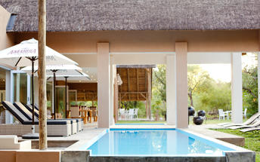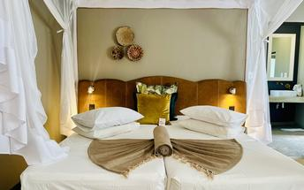

|  |
| --- |
| Directions - Mushara Bush Camp to Toshari Lodge |
| **Distance:** 196.98km **Travel Time:** 3:12 hours |
| **GPS co-ordinates for Toshari Lodge:** S 19° 33' 21.927" E 15° 52' 37.684" |
| * Head west on C38 (20.4 km)http://schemas.openxmlformats.org/drawingml/2006/picture * Turn left to stay on C38. Destination will be on the left (177 km) |
| *Directions supplied by Google.* |

### Basis

Dinner, Bed and Breakfast

## Day 7: Toshari Lodge, Etosha South (Tue, 11 February)

### Basis

Dinner, Bed and Breakfast

## Day 8: Mountain Peak Game Lodge, Damaraland (Wed, 12 February)

### Damaraland

This vast desert landscape is known as one of the most beautiful regions in Namibia. Huge, untamed and ruggedly beautiful, Damaraland is an exceptionally scenic landscape featuring open plains, ancient valleys and spectacular rock formations. The major attractions are the sacred Spitzkoppe, the Brandberg, Twyfelfontein, Vingerklip and the otherworldly Petrified Forest. Visitors can take in the dramatic vistas, catch a glimpse of the rare desert-adapted elephant, and enjoy spectacular stargazing in crystal-clear night skies from one of the many safari camps dotting Damaraland. Other popular activities include: guided drives, nature walks and visiting the local communities. Don’t miss the opportunity to view Damaraland's world-famous ancient rock art.

### Overnight: Mountain Peak Game Lodge

Mountain Peak Game Lodge and Camping is ideally located en-route between Swakopmund and Etosha NP. Situated on top of a hill overlooking other mountains and the Sub-Savannah plains, this property offers six modern, comfortable and spacious chalets, equipped with Wi-Fi, tea/coffee facilities, a private bathroom and a private outside viewing balcony, and 10 Luxury Camping sites (bring your own tent) situated in a ravine, Each offering an ablution block, braai facilities, solar energy and hot/cold water completely surrounded by the bush and wildlife. Guests can enjoy dinning at the onsite restaurant, which serve delicious modern Namibian stylized cuisines or relax in the bar with a refreshing drink. Additional amenities and services include an open lounge/dining area with spectacular views, a swimming pool, a sundowner deck, game drives, a sundowner drive, Milkyway dinner and various side trips.

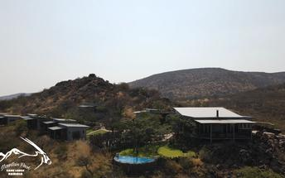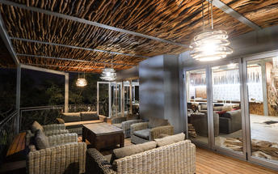

|  |
| --- |
| Directions - Toshari Lodge to Mountain Peak Game Lodge |
| **Distance:** 126.14km **Travel Time:** 1:10 hours |
| **GPS co-ordinates for Mountain Peak Game Lodge:** S 20° 13' 49.978" E 15° 37' 37.537" |
| * Head south on C38 toward D2695 (69.6 km)http://schemas.openxmlformats.org/drawingml/2006/picture * Turn right onto C39 (56.5 km) * Turn right. Destination will be on the right (7 m) |
| *Directions supplied by Google.* |

### Basis

Dinner, Bed and Breakfast

## Day 9: Brandberg White Lady Lodge, Brandberg (Thu, 13 February)

### Brandberg

Situated in northwestern Namibia, the Brandberg, meaning 'Fire Mountain', Massif is Namibia’s highest peak, at its zenith, the Königstein (King’s Stone), standing at a whopping 2573 metres above sea level. Named for the vivid shade of orange it sometimes turns at sunset, this is undoubtedly the main highlight of the region. The Brandberg has been sacred to the San people for centuries. The Tsisab Ravine at its base is permeated with over 45 000 ancient San rock paintings, including the famous ‘White Lady’. Visitors flock here to view this unique bushman painting, said to be over 2000 years old. Other popular drawcards include its untouched natural beauty and its free-roaming wildlife such as mountain zebra, kudu, springbok, and desert elephant.

### Overnight: Brandberg White Lady Lodge

### Reference No: Lux Tented Camp

Brandberg White Lady Lodge is located in Damaraland, Namibia. The property features a variety of accommodation options including lodge rooms, chalets, rustic tents, treehouses, and camping sites. The lodge rooms feature comfortable beds and en-suite bathrooms. Amenities include barbecues, a dining area, a bar, a lounge area, and swimming pools.

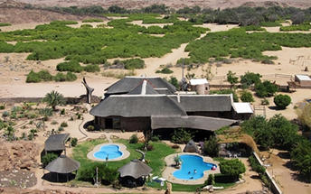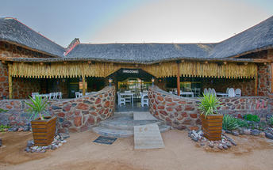

|  |
| --- |
| Directions - Mountain Peak Game Lodge to Brandberg White Lady Lodge |
| **Distance:** 191.42km **Travel Time:** 2:28 hours |
| **GPS co-ordinates for Brandberg White Lady Lodge:** S 21° 01' 19.052" E 14° 40' 59.427" |
| * Head south toward C39 (7 m)http://schemas.openxmlformats.org/drawingml/2006/picture * Turn right onto C39 (66.0 km) * Turn left onto C35 (102 km) * Turn right onto D2359 (14.4 km) * Turn right (8.0 km) * Turn left (0.7 km) * Turn left (56 m) |
| *Directions supplied by Google.* |

### Basis

Bed and Breakfast

## Day 10: Brandberg White Lady Lodge, Brandberg (Fri, 14 February)

### Basis

Bed and Breakfast

## Day 11: Swakopmund Sands Hotel, Swakopmund (Sat, 15 February)

### Swakopmund

Set along Namibia's spectacularly scenic coast, the seaside town of Swakopmund is known for its wide-open avenues, colonial architecture, and its surrounding otherworldly desert terrain. Founded in 1892 as the main harbour for German South-West Africa, Swakopmund is often described as being more German than Germany. Now a seaside resort town, Swakopmund is the capital of the Skeleton Coast tourism area and has plenty to keep visitors happy. The quirky mix of German and Namibian influences, adventure options, laid-back atmosphere and cool sea breeze make it a very popular Namibian destination. Visitors can look forward to a number of exciting activities including: quad biking, horse riding, paragliding, fishing, sightseeing and fascinating desert tours.

### Overnight: Swakopmund Sands Hotel [View iBrochure](https://wetu.com/iBrochure/43610_34719)

Located on Swakopmund’s Platinum Mile, Swakopmund Sands Hotel boasts a prime location within walking distance of the city centre, tourist attractions, restaurants, Jetty and the beach. Our accommodation offers great views, stylish comfort, top-class amenities, and warm Namibian hospitality.  
  
Start your day with a delicious breakfast and exceptional coffee from local Namibian roasters. Our rooms range from Classic, Luxury Rooms, Luxury Suites and Family Rooms, catering to all types of travelers. For small groups or self-drive clients, the Swakopmund Sands Cottage provides a cozy alternative with an amazing view of the Jetty.  
  
Our newest addition is an intimate in-house bar area, perfect for pre-dinner or sundowner drinks. Guests can also enjoy relaxing on-site massage treatments, ensuring a rejuvenating stay. Experience the best of Swakopmund with comfort and convenience at Swakopmund Sands Hotel.

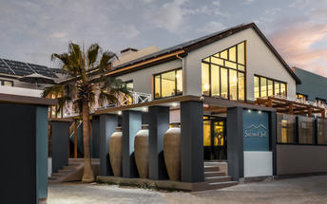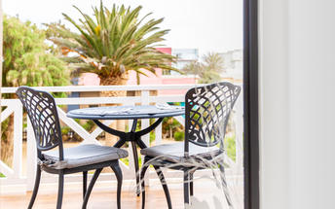

|  |
| --- |
| Directions - Brandberg White Lady Lodge to Swakopmund Sands Hotel |
| **Distance:** 229.58km **Travel Time:** 2:50 hours |
| **GPS co-ordinates for Swakopmund Sands Hotel:** S 22° 41' 6.549" E 14° 31' 24.530" |
| * Head north (56 m)http://schemas.openxmlformats.org/drawingml/2006/picture * Turn right (0.7 km) * Turn right (2.1 km) * Continue straight (6.0 km) * Turn left onto D2359 (14.4 km) * Turn right onto C35/M76 (13.1 km) * Turn right to stay on C35/M76 (115 km) * Turn left onto C34/D2301. Continue to follow C34 (4.4 km) * Turn right to stay on C34 (0.6 km) * Turn left to stay on C34 (62.9 km) * Turn right to stay on C34 (7.9 km) * At the roundabout, take the 2nd exit (76 m) * Continue onto Henties Bay Rd/Nordring (0.6 km) * Turn right onto Mittel St/Tobias Hainyeko. Continue to follow Tobias Hainyeko (1.4 km) * Turn right onto Sam Nujoma Ave (0.3 km) * Turn left onto Am Zoll/Strand St (0.7 km) * Turn left. Destination will be on the left (23 m) |
| *Directions supplied by Google.* |

### Basis

Bed and Breakfast

## Day 12: Swakopmund Sands Hotel, Swakopmund (Sun, 16 February)

### Activities

|  |
| --- |
| Levo Tours Morning Seal & Dolphin Tour Walvis Bay |
| Levo Tours Afternoon Sandwich Harbour Trip |

#### Levo Tours Morning Seal & Dolphin Tour Walvis Bay

Guests can spend their morning touring Walvis Bay's harbour. They will take in the beautiful isolated lighthouse built in the middle of nowhere, go to the wreck and the oyster farms in the beautiful bay, meander through Pelican Point while spotting birds and sea life, including everything from seals and dolphins to whales and turtles, all while enjoying a decadent picnic on deck with champagne, oysters and more.

#### Levo Tours Afternoon Sandwich Harbour Trip

Guests can have a 5-hour adventure exploring stunning Sandwich Harbour, as well as the Walvis Bay Lagoon, the salt pans, and enjoying some great bird watching. They can experience the crashing waves of the sea on one side, and the soaring heights of the sand dunes on the other in Sandwich Harbour, and look out for ostrich, springbok and jackals while driving through the dry Kuiseb Delta. The dunes will be braved to get there, dipping and cresting the sand waves, and creeping slowly down a slipface to hear the dune roar a greeting. Should the tides be against the tour, and the seas cut the trip off from the lagoon, the mighty dunes will be climbed to a viewtop instead. Included in this tour are some delicious platters, soft drinks, Namibian beer, juice, and real filter coffee.

### Basis

Bed and Breakfast

## Day 13: Swakopmund Sands Hotel, Swakopmund (Mon, 17 February)

### Basis

Bed and Breakfast

## Day 14: Rostock Ritz Desert Lodge, Gamsberg (Tue, 18 February)

### Gamsberg

Lying east of the Namib-Naukluft Desert, in Central Namibia, the Gamsberg area is home to the majestic Gamberg Mountain, dubbed Namibia's 'table mountain'. This area is a mecca for 4x4 enthusiasts, who tackle the steep Gamsberg Pass, a gravel road cutting through the rugged terrain. It is Namibia's highest, longest and most scenic pass overlooking the beautiful Kuiseb River in the valley below. Visitors can enjoy superb stargazing opportunities as there is no light pollution, hike along the trails traversing the Gamsberg Mountain, which stands at an impressive elevation of 2347 metres above sea level; and explore the Gamsberg Nature Reserve, home to indigenous plant life and a variety of wildlife.

### Overnight: Rostock Ritz Desert Lodge

The Rostock Ritz Desert Lodge, located on a 12,000-hectare property on the edge of the Namib Desert, consists of unique, semi-subterranean rock “igloos” aesthetically integrated with the natural surroundings. Accommodation consists of 16 fully equipped standard double rooms and 3 suites with views over the desert. Aside from lying by the pool and enjoying the spectacular view activities include hiking to the natural springs in the Gaub and Ubib canyons, 4 hour 4 x 4 drives to the rock art cave paintings or simply enjoying a 2 hour sundowner drive.

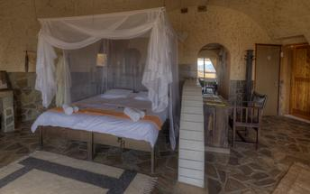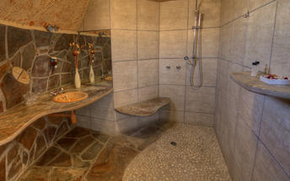

|  |
| --- |
| Directions - Swakopmund Sands Hotel to Rostock Ritz Desert Lodge |
| **Distance:** 225.04km **Travel Time:** 2:57 hours |
| **GPS co-ordinates for Rostock Ritz Desert Lodge:** S 23° 33' 33.877" E 15° 50' 35.234" |
| * Head west toward Am Zoll/Strand St (23 m)http://schemas.openxmlformats.org/drawingml/2006/picture * Turn right onto Am Zoll/Strand St (0.2 km) * Turn right onto Rhode Allee (0.6 km) * Turn right onto Nathaniel Maxuilili/B2 (31.3 km) * Continue onto B2 (0.6 km) * At the roundabout, take the 1st exit onto C14/M36. Continue to follow C14 (186 km) * Turn left (3.7 km) * Continue straight (2.7 km) |
| *Directions supplied by Google.* |

### Basis

Bed and Breakfast

## Day 15: Le Mirage Resort & Spa, Sossusvlei (Wed, 19 February)

### Sossusvlei

Located in the scenic Namib-Naukluft National Park, Sossusvlei is where you will find the iconic red sand dunes of the Namib. The clear blue skies contrast with the giant red dunes to make this one of the most scenic natural wonders of Africa and a photographer's heaven. This awe-inspiring destination is possibly Namibia's premier attraction, with its unique dunes rising to almost 400 metres - making them some of the highest in the world. These iconic dunes come alive in morning and evening light and draw photography enthusiasts from around the globe. Sossusvlei is home to a variety of desert wildlife including oryx, springbok, ostrich and a variety of reptiles. Visitors can climb 'Big Daddy', one of Sossusvlei’s tallest dunes; explore Deadvlei, a white, salt, claypan dotted with ancient trees; or for the more extravagant, scenic flights and hot air ballooning are on offer, followed by a once-in-a-lifetime champagne breakfast amidst these majestic dunes.

### Overnight: Le Mirage Resort & Spa [View iBrochure](https://wetu.com/iBrochure/43610_10424)

Le Mirage Resort & Spa is a one-of-a-kind oasis nestled in the Namib Desert, just 21 km from the Sesriem gate to Sossusvlei, making it an ideal base for exploring the world’s highest dunes.

Guests can unwind in 8 Camelthorn rooms or 19 Oasis rooms, each equipped with en-suite facilities, air-conditioning, a mini bar, and coffee & tea amenities. The lodge’s unique castle-like structure provides a cool retreat from the desert’s harsh climate.

Dining at the spacious restaurant is a delightful experience, offering a fusion of European and Namibian cuisine. After a day of adventure, the Mystique Spa offers relaxation with massages, pedicures, manicures, and de-stress treatments.

The resort’s large courtyard, with its palm-shaded swimming pool, provides a tranquil escape. Adventure awaits with quad bike tours, nature drives, scenic flights, and hot air ballooning, making Le Mirage Resort & Spa a luxurious desert sanctuary.

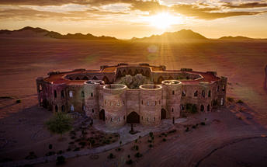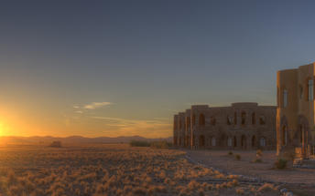

|  |
| --- |
| Directions - Rostock Ritz Desert Lodge to Le Mirage Resort & Spa |
| **Distance:** 156.21km **Travel Time:** 2:08 hours |
| **GPS co-ordinates for Le Mirage Resort & Spa:** S 24° 40' 58.709" E 15° 48' 56.053" |
| * Head northwest (2.6 km)http://schemas.openxmlformats.org/drawingml/2006/picture * Keep left (3.8 km) * Turn left onto C14 (44.3 km) * Turn right onto C19 (71.1 km) * Turn right onto D826 (11.9 km) * Turn left onto C27 (22.4 km) * Turn right (0.1 km) |
| *Directions supplied by Google.* |

### Basis

Dinner, Bed and Breakfast

## Day 16: Le Mirage Resort & Spa, Sossusvlei (Thu, 20 February)

### Activities

|  |
| --- |
| Dead Vlei |

#### Dead Vlei

This ancient clay pan was once an oasis, studded with acacias and fed by a river that suddenly changed course, leaving the earth to dry up along with the trees it previously supported. So dry were the climatic conditions that the trees never decomposed – instead they were entirely leached of moisture so that today, 900 years later, they remain as desiccated, blackened sentinels dotting the pan’s cracked surface. Surrounded by the red-pink dunes of the Namibia Desert, they create a surreal spectacle that is a photographer's dream.

### Basis

Dinner, Bed and Breakfast

## Day 17: Le Mirage Resort & Spa, Sossusvlei (Fri, 21 February)

### Basis

Dinner, Bed and Breakfast

## Day 18: Namibgrens Guest Farm, Gamsberg (Sat, 22 February)

### Gamsberg

As previously described

### Overnight: Namibgrens Guest Farm

The farm Namibgrens runs in the Rabie family since 1940. The old spacious farmhouse has been renovated and turned into a relaxed haven surrounded by a lovely garden. The summer temperatures is not very high, 10°C lower than that of the Namib desert and 5°C lower than Windhoek.

The large garden and abundance of water create an ideal environment for bird watchers with a variety of all types of species. Views from the 1850 meter high escarpment into the Namib desert are breath-taking. The farm can be explored by foot on well marked hiking trails from 2 hours to 3 days or by going on a 2-3 hour game / farm drive. A 4X4 self-driving trail takes the visitor on a challenging and picturesque adventure, with overnights (Granite Rock Camp) and camping grounds at the farmhouse and in the mountains. For the mountaineer, on offer are hiking trails up and around mountains 2700 meter high.

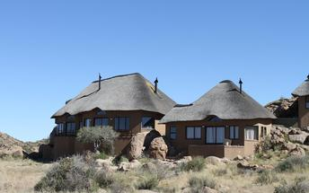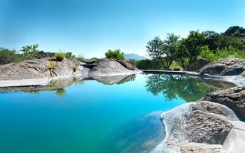

|  |
| --- |
| Directions - Le Mirage Resort & Spa to Namibgrens Guest Farm |
| **Distance:** 159.50km **Travel Time:** 2:15 hours |
| **GPS co-ordinates for Namibgrens Guest Farm:** S 23° 37' 22.059" E 16° 14' 52.438" |
| * Head northeast (77 m)http://schemas.openxmlformats.org/drawingml/2006/picture * Slight left toward C27 (60 m) * Turn left onto C27 (22.4 km) * Turn right onto D826 (11.9 km) * Turn left onto C19/M36. Continue to follow C19 (71.1 km) * Turn left onto C14 (9.3 km) * Turn right onto D1275 (44.3 km) * Turn left. Destination will be on the left (0.4 km) |
| *Directions supplied by Google.* |

### Basis

Dinner, Bed and Breakfast

## Day 19: GocheGanas Lodge, Greater Windhoek (Sun, 23 February)

### Greater Windhoek

Windhoek, the capital of Namibia, lies at the heart of the country, encircled by magnificent mountains, expansive valleys, and fertile farmlands. The landscape of the Greater Windhoek area surrounding this bustling city is characterised by vast valleys, thick scrub, rocky hills, and covered in golden savannah. Visitors can explore the dry river beds and mountainous scrublands, as well as enjoy birding, leopard-spotting and view large quantities of wildlife in the north; visit the more arid eastern part with its olive, potato, and date plantations; explore the rolling hills of the Khomas Hochland Mountains in the west of the Greater Windhoek area and soak up the epic views along a number of scenic passes leading off the high plateau, including Bosua Pass, Gamsberg Pass, and Spreetshoogte Pass.

### Overnight: GocheGanas Lodge

GocheGanas Lodge is ideally situated in central Namibia, approximately 29 kilometres south-east of Windhoek. Accommodation options consist of 16 spacious and elegant suites with air conditioning, TVs, minibars, coffee-making facilities, and private decks. Guests can enjoy delicious meals and relax with drinks at the on-site restaurant and bar. The spa features 11 treatment rooms, swimming pools, a granite bath, fitness facilities, body and beauty treatments, and therapy showers.

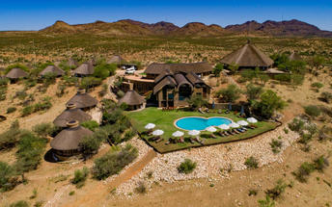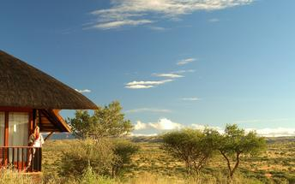

|  |
| --- |
| Directions - Namibgrens Guest Farm to GocheGanas Lodge |
| **Distance:** 184.60km **Travel Time:** 2:22 hours |
| **GPS co-ordinates for GocheGanas Lodge:** S 22° 48' 43.633" E 17° 12' 50.290" |
| * Head east toward D1275 (0.4 km)http://schemas.openxmlformats.org/drawingml/2006/picture * Turn left onto D1275 (6.2 km) * Turn left onto D1261 (22.7 km) * Turn right to stay on D1261 (33.5 km) * Turn left onto C24 (38.6 km) * Turn left onto B1 (68.8 km) * Turn right onto D1463 (9.7 km) * Turn right (3.4 km) * Turn right (0.5 km) * Slight left (0.2 km) * Slight right (0.6 km) |
| *Directions supplied by Google.* |

### Basis

Dinner, Bed and Breakfast

## Day 20: GocheGanas Lodge, Greater Windhoek (Mon, 24 February)

### Basis

Dinner, Bed and Breakfast

## Day 21: Immanuel Lodge, Windhoek (Tue, 25 February)

### Windhoek

As previously described

### Overnight: Immanuel Lodge [View iBrochure](https://wetu.com/iBrochure/43610_29060)

Immanuel Wilderness Lodge is located 20 km north of Windhoek. Surrounded by African Savannah in a growing suburb of the capital, the lodge offers a garden, outdoor pool and restaurant.

The Afro-chic rooms at Immanuel Wilderness Lodge are fitted with a private bathroom and tea-and-coffee making facilities. The beds are draped with a mosquito net. Linen and towels are provided.

Guests can start their day with a breakfast, which is served at the restaurant or on the terrace. Meals are available and the owner is a renowned chef.

If you are looking for a truly Namibian safari experience complete with personal service and warm hospitality, look no further than the exceptional Immanuel Wilderness Lodge.



|  |
| --- |
| Directions - GocheGanas Lodge to Immanuel Lodge |
| **Distance:** 64.33km **Travel Time:** 56 minutes |
| **GPS co-ordinates for Immanuel Lodge:** S 22° 22' 58.464" E 17° 03' 20.117" |
| * Head east toward Gocheganas Delivery Rd (0.9 km)http://schemas.openxmlformats.org/drawingml/2006/picture * Slight right (0.4 km) * Turn left (3.4 km) * Turn left onto D1463 (9.7 km) * Turn right onto B1 (14.7 km) * Turn left (1.3 km) * Turn right onto the ramp (2.7 km) * Keep left (0.3 km) * Keep right (1.3 km) * Merge onto Western Byp (4.6 km) * Continue onto Western Byp (2.5 km) * Continue onto Western Byp (3.3 km) * Continue onto A1 (17.1 km) * Take the exit (0.5 km) * Turn left (1.1 km) * Turn left. Destination will be on the left (0.3 km) |
| *Directions supplied by Google.* |

### Basis

Bed and Breakfast

## Day 22: End of Itinerary (Wed, 26 February)

### Basis

Bed and Breakfast

### Urgent Contact Numbers

|  |  |  |  |
| --- | --- | --- | --- |
| **Company Name** | **Telephone** | **Email Address** | **Contact Person** |
| U Xplore Tours and Safaris | +264818100755 | barbara.hanekom@gmail.com | Barbara Hanekom |